**SPEAKING – PART 2**

1. **Learning English**

**You want to improve your English speaking skills.**

* **Joining an English class at Centre**
* **Joining an English club**
* **Talking to foreigners in public places**

**Which is the best choice for you?**

I would like to share my thought on the situation . I believe choosing joining an English class at Centre í the best choise for seversl reasons .

Firstly, styding English at class help me can stydy experiended teacher, they can correct my mistake or give me good information.

Secondly, I can leaning with many different topic, foe example , everyday I can learn 1 topic and taking about it.

Additional, in class, I can studying with many member together, we can di

Although study English club and talking to foreigners in public placeshassome advantages but I think it is not a good choise

I’m thinking about a way to improve my English speaking skills among three options. Joining an English class at Centre, joining an English club or talking to foreigners in public places. In my opinion, talking an English course is the best choice for some reasons.

Firstly, I can study with experienced teachers. They can correct my mistakes or give me useful materials. Secondly, I can practice speaking English with many different topics. For example, each lesson I often learn about one topic. As a result, at the end of the course, I’m able to speak to others about different things.

However, there are several reasons why I don’t choose the other options, I don’t choose to join an English club because it’s so noisy, I can’t hear what other people are saying. Besides, talking to foreigners in public places isn’t my choice since I can only speak about very common topics like name, food, family, or weather.

In short, I believe that going to an English class is the best way for me to improve my

English speaking skills.

1. **Your family are choosing an activity for your parents’ wedding anniversary. Which one is the best choice:**

* **A party at a restaurant**
* **Going on holiday**
* **A party at home**

I’m thinking about an activity for my parents’ wedding anniversary among three options: a party at a restaurant, going on holiday or a party at home. I suppose that a party at home would is the best choice because of some following reasons.

Firstly, a party at home can create a cozy and comfortable atmosphere. A familiar environment helps people become closer to each other. Secondly, my family can save a lot of money. We can use this amount of money for other things like food, drinks and so on. Finally I have the freedom to choose the food and decorate the party according to what I like.

There are some reasons why I don’t choose the other options. Organizing a party at restaurants or going on holiday may be expensive. Besides, going on holiday is not my choice because I have to take a lot of time to make a plan about where to go and what to do.

In short, I think that a home party is the most ideal to celebrate my parents’ wedding anniversary.

1. **House**

**You are going to get married soon. Where would you choose:**

* **Live with your parents**
* **Buy a flat near the city center**
* **Buy a house 10 kms far away**

If I were in this situation, I would believe that buying a flat near the city center is the best choice among three options: living with parents, buying a flat and buying a house 10 kms away due to some reasons.

Firstly, buying an apartment tends to be cheaper than a house. Besides, if is safe to live there because there is security guard 24 hours a day. The second reason is that living in a flat gives me a good chance to make friends with other people because there are many families living on the same floor.

Finally, as the flat is located near the city center, it is convenient to travel to many places, essentially the workplace. Therefore, I can save time and money of travelling. There are some reasons why I don’t choose the other options. Living with parents is not my choice because my husband and I may not have private space or have freedom to do what we want. I don’t choose to buy a house 10 kms far away because is it not convenient to go to work. Moreover, buying a house is expensive.

In short, for all reasons I put above, I will choose to buy an apartment near the city center as the most choice.

1. **Hobby**

**You have a Sunday evening out with your friends:**

* **Seeing a movie**
* **Going shopping**
* **Singing karaoke**

**Which one would you choose?**

I am thinking about an activity to do with my friends on a Sunday evening among three options: seeing a movie, doing shopping or singing karaoke. In my option, watching a movie is the best choice for several reasons.

Firstly, my friends and I are big fans of watching movie so it is very interesting to go to the cinema and enjoy our favorite films at the weekend. Moreover, seeing movies is a good way for me to reduce stress after school. When watching comedy and romantic films, I feel very relaxed and comfortable. Finally, it is a great chance to spend time with friends. For example, we can chat with each other before and the film.

I don’t choose the other options because of some reasons. About shopping, I personally think that it is often a hobby for women, not for man so it is not suitable for my friends including both boys and girls. Besides, going shopping is a waste of time. Singing karaoke is not my choice since it is very noisy and we cannot chat with each other. Moreover, noise is bad for our health.

To sum up, from my point of view, seeing a movie is the best choice for me and my friends on a Sunday evening.

1. **Job**

**You’re finding a part time job to practice English. There are 3 types of jobs:**

* **A telephone operator – nhan vien truc ddien thoai**
* **A hotel receptionist – nhan vien le tan khach san**
* **A tourism agent – dai ly du lich**

**Which option do you think the best choice?**

If I had to choose 3 types of jobs: a telephone operator, a hotel receptionist and a tourism agent. I suppose that a tourism agent would be the most idea part time job because of some reasons.

Firstly, I have a lot of chances to communicate with different countries directly. This helps me learn more skills such as communication skills and English skills. Besides, I can broaden my relationship by making more new friends. Moreover, I can gain more knowledge when going to many beautiful places in Vietnam and around the world.

Therefore, I know more about the languages and cultures of these places. Finally, a tourism agent is an interesting job because I can explore many new things when travelling to new places.

There are some reasons why I don’t choose the other options. Firstly, becoming a telephone operator or a hotel receptionist is a boring job because I have to do the same thing every day. Besides, I will not have a chance to communicate with customers directly.

In short, for all reasons I put above, a tourism agent is my choice for a part time job.

1. **Travel**

**Your family is going to plan a trip:**

* **A seaside resort**
* **A lakeside hotel**
* **A countryside cottage – ngoi nha nong thon**

**Which one is the best choice?**

If I were in this situation, I would believe that a seaside resort is the most ideal choice among three options: a seaside resort, a lakeside resort and a countryside cottage because of the following reasons.

First of all, it is easy and fun to organize different activities in a resort with a large space. There are many activities for my family to do on the beach such as playing team sports, going swimming and so on. Taking part in these activities helps my family members become close to each other. Secondly, as it is getting hot, it is suitable for us to help a trip to the beach. It is great to play water sports in hot weather, for example windsurfing, swimming and driving. When playing these sports, my family will feel more relaxed and become healthier.

There are some reasons why I don’t choose the other options. Firstly, it is difficult to organize different activities in places with small spaces like a hotel and a cottage. Besides, there are not many interesting activities to do or beautiful views to see in these places.

In short, with all reasons above, a beach resort is the best choice for my family to enjoy the trip.

1. **Hometown**

**You are going on a 3 day holiday. Which option is the best choice:**

* **Danang**
* **Hanoi**
* **Hue**

If I had a decide among three options: Da Nang, Hanoi and Hue for 3-day holiday, I would choose Da Nang as the best choice because of the following reasons.

First of all, I can visit beautiful beaches in Danang. It is great to walk along the beach and have the fresh air. Besides, I have a chance to enjoy beautiful views on the beach such as watching the sunset and sunrise. Moreover, I can eat a lot of seafood like crabs, lobsters and so on. The seafood here is fresh, delicious and cheap. Finally, there are many activities to do on the beach such as playing team sports, going swimming and so on. When playing these sports, I will feel more relaxed and become healthier.

There are some reasons why I don’t choose the options. Firstly, it is boring to go on holiday in Hanoi because I have visited famous places here many times. Besides, it is difficult to move around in Hanoi during rush hours because traffic jams are serious. Moreover, Hue is not my choice because I do not loke to visit historical places there.

In short, with all reasons I put above, Danang is my best choice for a 3-day holiday.

1. **Food**

**Your family are choosing where to hold your sister’s birthday party:**

* **At home**
* **At a restaurant**
* **In the park**

**Which do you think is the best choice for her?**

I am thinking about a place to organize my sister’s birthday party among three options: at home, in a restaurant and in the park. I believe that holding a party at home is the best choice because of some following reasons.

Firstly, a party at home can create a cozy and comfortable atmosphere. A familiar environment helps everyone become closer to each other. Secondly, my family can save a lot of money. We can use this amount of money for other things like food, drinks and so on. Finally, my family have the freedom to choose the food and decorate the party according to what we like.

There are some reasons why we don’t choose the other options. Organizing the party in a restaurant is not my choice because it may be very expensive. About holding the party in the park, it is very noisy so we cannot talk with each other comfortably.

In short, for all the reasons above, I think that a home party is the most ideal to hold my sister’s birthday party.

1. **Health**

**Your friend wants to improve her health. She is thinking of:**

* **Jogging in the park**
* **Going to the gym**
* **Doing yoga in a yoga club**

**Which is the best option?**

My friend is thinking about of an activity to improve her health among three options: jogging in the park, going to the gym or doing yoga in the yoga club. If I were her, I would choose to go to the gym as the best choice because of some following reasons.

Firstly, doing gym is cheaper than doing yoga in club. Therefore, she can save an amount of money. Secondly, she can take part in different activities such as dancing, swimming, do squats and so on. It means that she has many choices to do what she wants. It is more interesting than just doing yoga or jogging,

The final cause is that she can use good equipment. In the gym, there are a lot of modern facilities with high quality, so she can feel very comfortable and excites when doing exercise.

There are some reason why I don’t choose the other options. Firstly, it is boring to go jogging in the park or doing yoga instead of doing many activities in the gym. Besides, the fee to join a yoga club is expensive so doing yoga is not my choice.

In short, for all the reasons above, I think going to the gym is the best activity for my friend to improve her health.

1. **Transport**

**A group of people is planning a trip from Danang to Hanoi. Three means of transport are suggested:**

* **By train**
* **By plane**
* **By coach**

**Which is the best choice?**

If I had to decide a from of transport for a group of people going in a trip from Danang to Hanoi among three options: by train, by plane and by coach, I suppose that going by plane would be the best choice because of some following reasons.

First of all, going by air is the safest among three types of transport. People don’t have to worry about road accidents. Secondly, going by plane is very fast, therefore, they can save a lot of time. It only takes them one hour to fly from Danang to Hanoi. Finally, people can enjoy good services on the planes. Flight attendants will serve them food and drinks, so they can feel very comfortable during the journey.

There are some reasons why I don’t choose the other options. Firstly, going by train is too slow so it wastes people a lot of time. Moreover, going by coach is not my choice because it may be very dangerous. Besides, there are not good services on a coach so this may make people uncomfortable.

To sum up, t think that plane is the most convenient means of transport for people to travel from Danang to Hanoi.

1. **Communication**

**You are going to contact your close friend. Which option is the best choice:**

* **An email**
* **A post mail**
* **A postcard**

I am thinking about a way to contact my close friend among three options: an email, a post mail or a postcard. In my option, email is the most ideal choice because of some following reasons.

Firstly, it is a quick way to keep in touch with my friend. It only takes a few seconds or minutes to send and reply an email. Besides, I don’t have to spend any money on contacting my friend because it is free. Moreover, using emails is a convenient way to send videos and photos. It is difficult or impossible to do that when I use a post mail. The final reason is that it is able to send information to a lot of people.

There are some reasons why I don’t choose the other options. Firstly, a post mail is not a good idea because it takes a long time to write and send the letter. Besides, the letter may be lost. In addition, I don’t choose a postcard because it is not popular in Vietnam and it cannot show long messages.

In short, for all reasons above, writing an email is my best choice to contact my close friend.

1. **The internet**

**You are going to graduate from university and look for a job. Where would you find information:**

* **The person who is doing that job**
* **The internet**
* **Newspaper**

I am thinking about a way to look for a job. Among three options: the person who is doing that job, the internet or newspaper. I think that asking the person who is doing that job is the best choice because of some following reasons.

First of all, this person can provide exact information about the position I want to get. For example, he can help me know about the salary, the working environment and so on. Therefore, I can consider these things to see whether it is suitable for me or not. Secondly, he can share with me his experience or give me good advice about the job. As a result, I can easily get the job, even get promotion after I am accepted.

Ther are some reasons why I don’t choose the other options. Firstly, the internet is not a good choice because the information about some jobs might not be correct. Secondly, I don’t choose newspaper because it is not updated quickly. Besides, it takes lots of time to find a suitable job in a newspaper.

In short, for all reasons above, I think that finding information about the job from the person who is doing it is the most ideal option.

1. **Festival**

**You are considering a birthday present for a friend. There are three suggestions:**

* **Clothing item**
* **A book**
* **A pair of movie tickets**

**Which one would you choose?**

I am thinking about a birthday present for a friend among three options: clothing item, a book or a pair of movie tickets. I think that a book is the best choice because of some following reasons.

First of all, my friend is keen on reading books. Therefore, if I give her a book that she likes, she will be very excited and happy. The second reason is that reading a book helps her relax after hard-working hours. Finally, a book is a great present for her to improve her knowledge. I can choose to buy a book that is useful for her work. It is both relaxing and informative.

There are some reasons why I don’t choose the other options. About a clothing item, it is difficult to choose a suitable one because I don’t know her size or what kind of clothes she likes. Moreover, a pair of movies tickets is not my choice because she doesn’t like watching movies.

In short, for all reasons above, I believe that a book is my best choice as a birthday present for my friend.

**SPEAKING – PART 3**

1. **Learning English has many benefits**

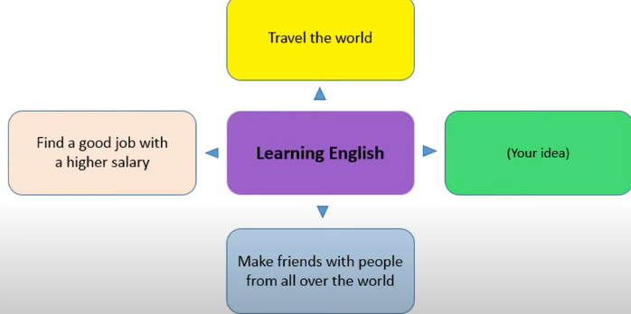

English is very important to our modern lives as it is the global languages. Therefore, learning English brings many advantages.

Firstly, people can travel the world with good English. As English is spoken in many parts of the world, if people speak English frequent, they can communicate with others without fear.

Secondly, people can find a good job with a higher salary if they know English well. It’s true that nowadays people can do business abroad easily. For example, many foreign companies invest in Vietnam, therefore people can easily get a well- paid job.

Finally, people are able to make friends with people from all over the world. This is because they can speak the same language which is English.

To sum up, it’s very important to learn English so people should be encouraged to learn it.

1. **Establishing family rules has positive effects on children**

In my option, it is important to develop family rules because these rules are useful for children in many ways.

First of all, family rules help children learn to have good manners. For example, some basic manners like using polite words at home teach children how to communicate with others.

Secondly, when following family rules, children can learn to have good behaviors. Specifically, children know what behavior is or isn’t acceptable in their family. This also helps children know how to behave well in different situations in life.

Last but not least, family rules teach children about safety rules such as wearing seat belts in the car or being careful with sharp knives. These rules help to protect kids and keep them safe everywhere, not just at home.

In short, establishing family rules has many good effects on children.

1. **House**

**There are several factors to consider when buying a house.**

It is clear that buying a house is one of the most important things in people's life; therefore, they need to consider factors when buying it.

The first thing is the location. A good location can help people go to work convenient so they can save time and transportation cost.

Another factor for people to care about is neighborhood. People need to look for information about the area where they will live and the people living there. It is important to find a house with friendly neighbors. Besides, people can find out if the area is safe and clean to live or not.

The last factor to consider is facilities. They need to learn whether facilities like water supply, parks and shopping centers are available or not. Moreover, it’s important check if the house is close to facilities like the workplace, children’s school, hospital and so on.

To sum up, people should consider factors such as location, neighborhood and facilities when buying a house to have a comfortable life.

1. **Playing sports in beneficial for young people**

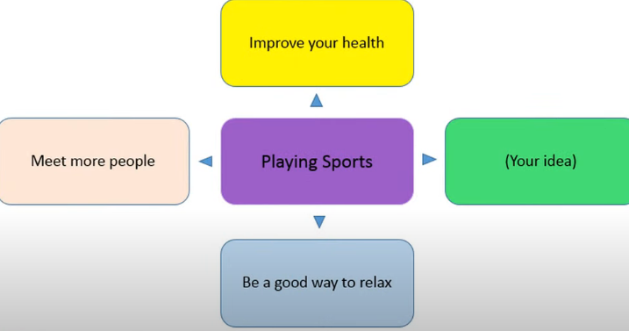

Nowadays, young people like playing sports because it has many benefits.

First of all, it is the best way to improve people's health. When doing sports, people burn a lot of calories; therefore, they can keep fit and stay healthy. Besides, it helps them avoid some serious diseases.

The second advantage is that people have more chances to meet others. For example, when playing some team sports like football and volleyball, people can make more new friends and broaden their relationship.

Finally, it is a good way to relax after hard-working hours. Playing sports can make stress disappear and make people become happy.

In short, young people should play sports more regularly because it is good for them in many ways.

1. **There are some factors causing stress at work**

Nowadays, it is true that more and more people feel stressed at work. There are several causes of this problem.

First of all, working conditions are poor. For example, employees might have to work in an environment with a lack of facilities. As a result, they feel bored and work ineffectively.

The second reason is that they have to deal with too much work. Working under pressure might rick their health; for example, it makes them feel tired.

The final factor causing stress is the bad management. For example, people might not receive support from their co-workers and employers.

In short, stress at work is caused by several reasons including poor working conditions, too much work at the bad management.

1. **Travel - Visiting a foreign country is a valuable experience for us**

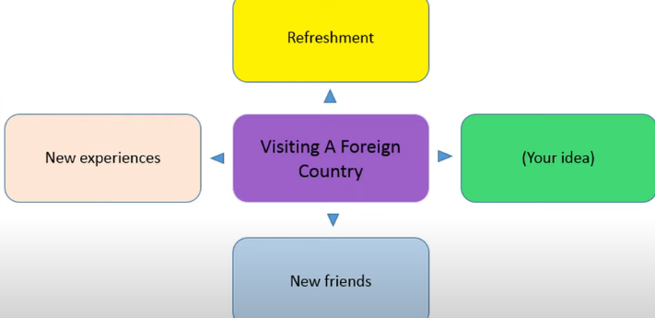

Travelling to a foreign country has become more and more popular because it brings people many advantages.

Firstly, travelling abroad gives people refreshment. It is a good chance for people to relax after hard-working hours.

Secondly, tourism can gain a lot of new experiences. For example, that can visit many famous places, taste new food, learn new culture, explore new things in different places and so on. Doing these activities also helps them broaden their knowledge.

The final advantage of visiting a foreign country is that people have a chance to meet people and make new friends. Therefore, they can share with each other about the cultures and people of their countries.

In short, travelling overseas gives people a lot of unforgettable experiences.

1. **Hometown – There are some benefits of living in the city**

Nowadays, people prefer living in the city because it brings them several benefits.

First of all, people have more chances for good jobs. There are many big companies and factories in large cities, so people can easily find work with a good salary. It is difficult to do that in the countryside or small cities.

Secondly, people can have better education when living in the city. In big cities like Hanoi and Ho Chi Minh City, there are famous universities where people can learn with excellent teachers and modern facilities.

The final advantage is that people can have a higher quality of life. For example, they can good health care service when they are sick or get a disease. This is because there are many central hospitals and international clinics in the big cities. Besides, city life is very convenient and comfortable because there are many entertainment facilities such as cinema and shopping malls.

In short, more and more people choose to live in the city to have a better life.

1. **Food – there are some drawbacks of fast food**

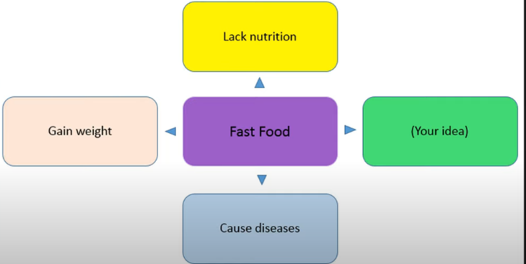

Nowadays, many people choose to eat fast food because of its convenience. However, it has some negative effects on people’s health.

The first disadvantage is that people lack nutrition. Most fast food contains unhealthy ingredients. For example, additives in fast food are bad for people’s health.

Secondly, it makes people gain weight easily. Fast food often has a lot of fat and sugar, therefore, people become fatter when eating too much of this food.

Finally, it causes many serious diseases. It fact, fast food contains a lot of sugar, fat, calories and cholesterol, so eating it too much can make people get many health problems such as heart disease, obesity and even cancer.

To sum up, people should not eat fast food to have good health.

1. **Health – there are several ways to have a healthy lifestyle**

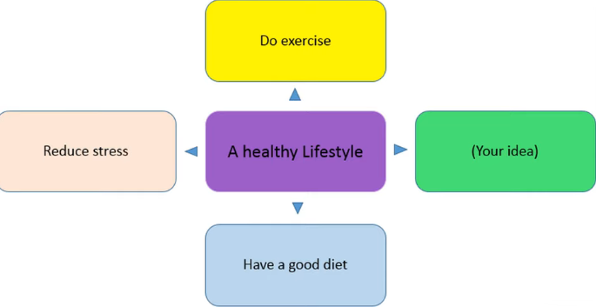

People can have a healthy lifestyle in many ways.

Firstly, they can do exercise regularly. Exercise is great way to help them keep fit and live longer. For example, going jogging for 30 minutes in the morning keep people healthier.

Secondly, people need to reduce stress to feel relaxed and calm, they should forget stressful work or study by doing different activities such as playing sports and listening to music. This a good for both their bodies and minds.

Finally, a good diet is important for people to have a healthy lifestyle. For instance, eating a lot of fresh fruit, vegetables and fish gives them more energy for whole day. Besides, they should avoid junk food like fast food and alcohol.

In short, people can do many things to keep healthy such as doing exercise, reducing stress and having a good diet.

1. **Travel – there are many advantages of going by bus**

Nowadays, the government encourages people to use public transport like bus to solve traffic problems. Therefore, more and more people choose to travel by bus because going by bus has many benefits.

The first advantage is that bus fares are very cheap. It costs only seven thousand dongs to buy a single ticket and it even gets cheaper to buy a monthly ticket. Therefore, people can save money.

Secondly, travelling by bus helps to protect the environment. If more people use buses and fewer people use cars and motorbikes, air pollution will be reduced.

Finally, going by bus is a good way to reduce traffic jams during rush hours. If people choose to travel by public transport such as bus, the number of private vehicles will decline; as a result, people can avoid traffic jams and travelling becomes easier.

To sum up, people should travel by bus more and more to save money, protect the environment and reduce traffic jams.

1. **Communication – Face to face communication is very important nowadays**

Today, people believe that face-to-face communication is becoming more and more important because it brings them many benefits.

The first advantage is that it helps people to express their feelings. People often show their feelings through their faces, so it is easy to know how they feel when we talk with them directly.

Secondly, people have a good chance to build personal relationship. It is easy to make friends with others or become closer to them when we communicate with them face to face.

Finally, chatting face to face helps to reduce misunderstanding. It is clear that people can easily understand each other when they see others’ facial expressions directly. Even is there is any problem, they can solve it right away.

In short, face to face communication is very useful and convenient for people to show their feelings, broaden relationships and decline misunderstandings.

1. **Internet – the internet is a good source to collect information**

Nowadays, more and more people find information on the internet instead of going on the library because it is a great source to get information.

Firstly, people can have easy access to the internet. It’s true that people can easily search for information on the internet on their mobile phones or computers if their devices have internet connection.

Secondly, the internet is a source of rich information. People can get information about many aspects of life such as education, culture and so on. For example, there are many educational websites for students to improve their knowledge.

Finally, people can collect information through the internet at a low cost or even for free. They only have to pay the internet bill every month. Besides, they can take many cheap or free online courses.

In short, the internet is a good way to get information because of its easy access, rich information and low cost.

1. **Festival – Tradition festival present important values**

Traditional festivals play an important role in people’s life because they present a lot of values.

First of all, traditional festivals help people to improve their spiritual life. Festivals give people the opportunity to forget all their worries and celebrate the positive side of life. Festivals help people to reduce stress and balance their emotions so they make people feel more relaxed and calm after hard-working hours.

Secondly, traditional festivals are good occasions to show community strength. When festivals take place, people around the country come to join. Therefore, these festivals bring people together and connect them with others. For example, when attending festivals like Tet, people can enjoy a happy time with their family members or friends.

Finally, festivals teach people about history and cultures. Vietnamese can learn about their origins or the culture and traditions of their country in the festivals like Lim festival and Hung King Temple festival.

In short, traditional festivals are necessary to people’s life because of their important values.